|  |
| --- |
|  |
| |  | | --- | | **DRAFT** | | Mobile Application  Use cases for  Rams Head group  Macintosh HD:Users:yikexue:Documents:iOS:training:RamsHeadGroup:RamsHeadGroup:RamsHeadGroup.png | |
| **By: Yike Xue** |
|  |

# Introduction

Mobile Applications are developed in support of worker productivity; an important aspect of application life cycle development is – rapid development, modularized coding, efficient and secure distribution, control and management of mobile applications to facilitate that applications meet quality standards, are secure and that corporate change management and governance policies are adhered to.

To provide an understanding of the implementation and how it would be used, the team developed few use cases to define how the process would work.

# Use Cases Survey

# Customer Mobile application

|  |  |  |  |
| --- | --- | --- | --- |
| No. | Use Case Name | Description | Benefits |
| 1 | Company Information | * Company information of Rams Head group * Company information of Software Merchant Inc. | Before using the app, the customers could have a basic knowledge about the app-related companies. It’s easy to click “continue” button to skip this page. |
| 2 | User Register | * Let customers input email and password to register an account * Show alert window indicating if registration succeed or not | Customers would know if their email is used as an existing account or they would be navigated to the next page with the new account. |
| 3 | User Login | * Let customers input email and password to register an account * Show alert window indicating if login succeed or not * Use Touch ID to login to an existing account | If the customers successfully login with the valid email and password, they would be automatically navigated to next page.  New Feature “Touch ID” makes life easier. |
| 4 | Forget/Reset Password | When customers forgot their password, they could reset it. | Great feature for forgettable users. |
| 5 | Beer List | Show beer type list, and when you select one of them, segue to the beer list of a certain type, then you can select a specific beer to view it detailed introduction.  Applied GCD when fetching data from the Internet.  Use core data to store data when you first time launch the app | Data is presented systematically.  Synchronous download on main thread with GCD  Users can view the data without Internet after the first time launch. |
| 6 | Location | Pick a destination location and then show location on map  See annotations on the map  Show current location  Click “Direction” button to start a navigation app to route | -Publicity |
| 7 | Live Music | Web view of yelp or google with default filter “live music” | -Publicity |
| 8 | Points | Show userID and reward point  Click the update button to view the updated points | View the real time points  After you redeem some points you can update the points |
| 9 | Scan Bill | Open a camera to scan barcode(such as QR code) then add point to the user account | Convenient for users to earn and redeem points |
| 10 | Events | Show events | -Publicity |
| 11 | Push Notification | Receive push notification | Allow users to receive the up-to-date message sent from server |

# Suggestions or future uses (market trends, for both apps)

|  |  |  |  |
| --- | --- | --- | --- |
| No. | Use Case Name | Description | Benefits |
| 1 | Live Music search | If the user has the Yelp app installed on the machine, when clicking “Yelp” in Live Music list, the Yelp app would automatically pop out instead of viewing search result in a webview. | Use mature app to do more search |
| 2 | Event page could be improved | Using cell class to designed a auto formatting cell with image and text box | Easy to add more events |
| 3 | Bill Scan(QR code scan) | Set up a reference table for the bill code and points | Let users add different points according to their payment |
| 4 | Forget password | Add some questions before reset the password | Verify the identity of users and prevent fraud execution |
| 5 |  |  |  |
| 6 |  |  |  |

**Activity Monitor Result(by Instrument):**

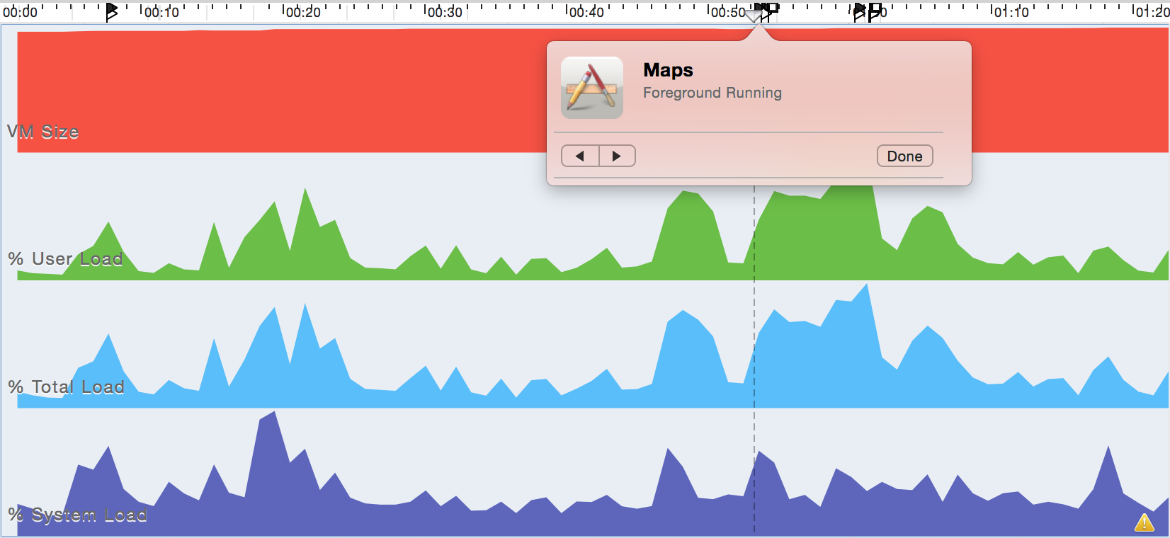

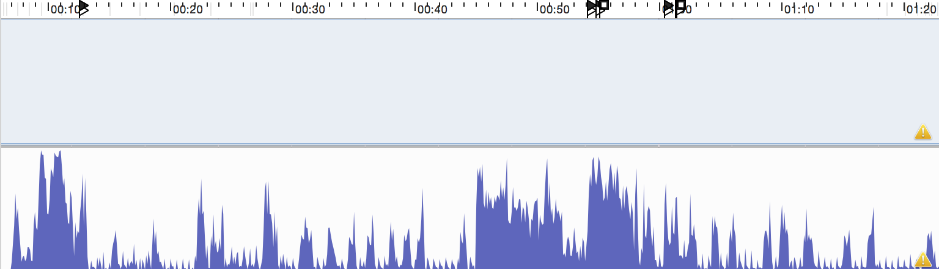

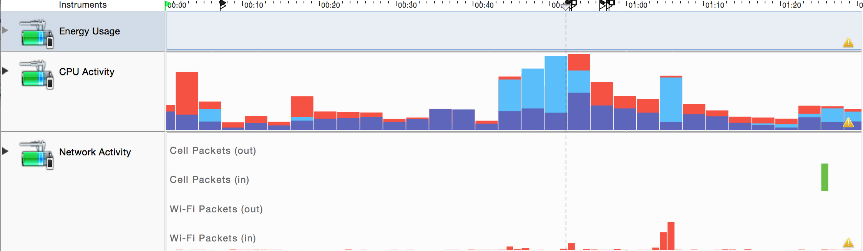

The peak value of User Load, Power usage and CPU usage is in the “LocationPage” process where we use the Core Location framework and current location service to open the Maps app and start the navigation.